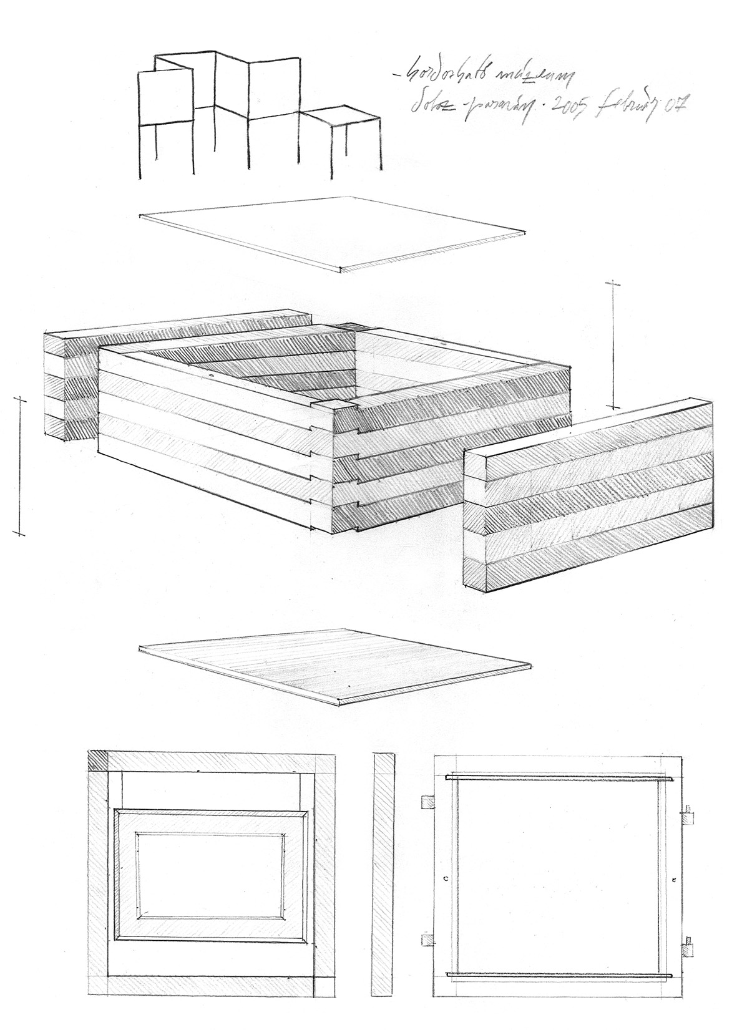
Portable Museum of Intremediate Spaces

An art-collection to be shown in unconventional spaces, to unusual audiences.

Presentaion

When selecting the works of art for this Museum we had in mind two basic principles: as a matter of subject all the artworks had to transmit a message that is related to intermediate spaces and as a matter of size they all had to be portable.
We know, of course, that there are no such things as regulations when it comes to the interpretation of works of art. However, by giving one possible interpretation, we would like to draw your attention on the various possibilities- even in our everyday life- for us to dwell in spaces that can be viewed as intermediate.

Let us start the presentation with the picture entitled “Nobody”, by Katalin Hervai (collography + colored lino-cut, 1997, 35x60cm). This is a self-portrait with the inscription of “ Niemand” (German for Nobody, No-one). The glowing face reminds us of a crumbled piece of paper set on fire. The personal experience behind this picture is that of oppression, the questioning of personal and artistic freedom.

We would like to draw your attention to another possibility to interpret “Nobody”. If I am nobody, than I can be nowhere. The word “nowhere” marks the place that does not exist, however it is still there, it exists, just like the word for it does.

Let’s see how Gergely Simon deals with this problem. He uses the smallest font size from the character set of a text editing program to produce a small inscription: “nincs”, which is the verb of nonexistence in Hungarian. But as we all see this inscription does exist. Understanding these two works of art this way, being nobody becomes an attitude. This attitude is essential in order to feel at home in intermediate spaces. No-one becomes someone, who’s view is far from being indifferent.

On Frigyes Kőnig’s “Field of sight”( serigraphy, 30x62cm)we cab observe the binocular visual area that results from the merging of the picture perceived by our eyes( practically this is the image our mind perceives when fixing our vision on one point ). This experience is a great opportunity to give thought to another complex problem, namely that of similarities and unsimilarities between different viewpoints.

Contact lenses of stone- Ferenc Varga found a pebble at a river-bank and polished it into a pair of contact lenses. He did so in order to make the closest contact between Man and Material, to have as close a view of the stone as possible. Is it possible to take a look at the stone from the inside? Is it possible for us to see ourselves from within? When wearing this pair of lenses, they become a part of our perception; our view becomes united with the stone itself. At the same time we know that the space between thought and material is infinite and we cannot possibly exclude the intermediate space, no matter how close they might get to each other.

The “Circus” of Kázmér Kovács (tint-drawing, 55x35cm ) is an amphitheatre, only it is turned inside out. The auditorium faces outwards, in fact it faces nothing. Because the building is turned inside out, the columns of the arcade form an inner court, where we can see a tree (roots in the soil, the foliage in the sky, with the trunk in between). We can also see a bicycle leaning on the wall, as a possible tool for displacement.

In the Circus there is a severe fight going on. We are now looking at József Szabó’s “Entwined Wrestlers” (mixed media, 85x68cm ). Here we see two bodies grown together, wrestling over an annihilating chasm. We are witnesses of an irrational fight, there can’t be any winner, as the looser will automatically pull him into the chasm.

The stone remains unchanged (?). The “Pseudo-cobblestone” of Gyula Pauer is a genuine fake (aluminium, 1971-1972, 10x15x22cm). No matter how real it appears to be, it cannot be properly used. We cannot walk on it, but through this cobblestone the street itself enters the Museum.

Here we are, in the middle of a crowd- Through his paper figurines Zoltán Balla offers the visitor a choice, at the same time facing us with interesting questions. May we walk over these little fellows to reach our goal (the exhibition for instance)? Do we have to intrude other people’s private spaces to get closer to the subject of our aim? How much does responsibility for others matter to us? Through our thoughts, words and actions we testify to the freedom of choice and that of the will.

“Bagatell”(meaning a small packet, a bundle) is the title of this relief done by György Jovánovics (Plaster, 2004, 15x15x9cm). It is light that gives meaning to this simple form; therefore it is only in the realm of light that its existence is justified.

Dora Mauer goes on a journey as well. In her painting entitled “Overlappings” (wood, water-color, 2002, 37x37cm) we can see an experience familiar to the most of us from our travels by plane. When we rise over the horizon, to our great surprise, shapes and lines we thought to be exact began to curve and become distorted. The three colored fields of the picture (red, green, and blue) overlap and form new fields to be colored. The coloring of these new fields is not done with the complementary colors, neither with the mixing of the overlapping colors. Dora uses colors she considers to be “friends” with the neighboring ones, so this is an absolutely subjective decision.

István Mikolaj Dabi: “The Blue Line” (colored photo 12x17,5 cm; monochrome 16x24cm).The two snapshots were taken on the blue line of the underground in Budapest. When we examine the two pictures we notice the difference instantly: one of the pictures (the colored one) was taken spontaneously, while the monochrome picture is a narrative photo, taken years after the first one and it indicates precise directing. On the first picture passengers of the underground are surprised by the unusual position of one man, hanging upside down from the handhold, while on the monochrome picture they remain indifferent. All the characters of the narrative picture are close friends or relations of István Dabi.

László Zagyva is looking for a home. So he draws a “House” (ink, 2004, 56x70cm). His house is floating. From whichever side we may look at this house we face the fronting, so practically the house is unfit to live in.

The body is floating too. On the painting of István Csákány entitled “Souldishes” the receiver, as well as the mediator body, is a dish. In spite of gravity, the receiver body-dish does not move towards the terrestrial, but it is aiming for celestial nourishment. The content of the dish, the heavenly manna glows like the first blush of dawn.

Dawn is the time between dream and sobriety, the awakening of light. The photography of Nemere Kerezsi, “Dawn” (crono-photography, 2005, 19x25cm) depicts the light-change between the light of the last star and the first raze of the Sun, by putting besides each other little segments of pictures shot at the same place over one sunrise.

Free-stream of the bodies. According to the article referred to in Tamás Szentjóby’s “Enhancement/5” (paper, ink, typewriter, 1969, 30x21cm)”Every citizen has the right to move freely within the borders of the country. Every citizen has the right to leave every country, including that of which he/she is citizen of and has the right to return to his/her home-country.” The line of the borders is an abstraction itself. The exact line of it exists only in theory; in reality it is only approximate. The quotation marks not only question the sealing of the frontier, but they also highlight the absence of freedom. This problem is still present nowadays, the only thing that changed since 1969, is the line of the borders.

Gusztáv Ütő: “Family Tree 2” (print, photo, 2005, 20x30cm). The print creates a bridge between those members of the family that are still alive and those who passed away, from the first known member, up until today. We are all but products of a very long chain-reaction. The photo depicts the artist, feeding his son, as the present “winners” of the process.

Tamás Kaszás (object, untitled) creates a fine balance by poking through a little piece of paper with a sewing needle and than placing a dust bunny on the tip of it.

Limit of tolerance. The board-game of Miklós Mécs “Why not be a Messiah?”(2002) is based on the Gospel. All parables and miracles are included either on the board or on the cards. There are some fields and cards however, with false prophecies and miracles that are not in accordance with the Gospel and some “candidates” may loose their way in an unguarded moment. After all someone has to take the place of the two thieves as well.

Nemere Kerezsi
2006.03.21

The presentation of these works of art was done with the consignement of the artists. Bibliography:
Kőnig Frigyes, Orbis Pictus Művészeti téranalízísek, Enciklopédia Kiadó, Budapest, 1997.
Jovánovics, Corvina Kiadó, Budapest, 2004.
Boros Géza, A szabadság kapujában-Kommentár egy Szentjóby-műhöz, Balkon, Budapest, 1999. www.kthm.org

